**Leader Overview**

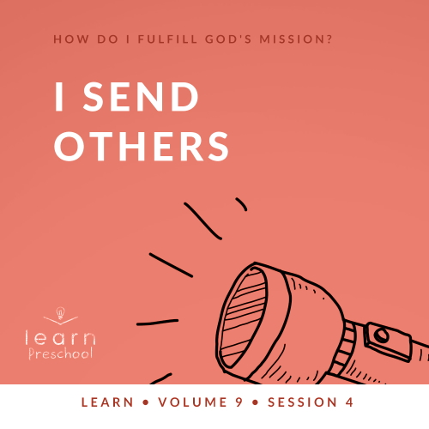

**Volume Overview**

**How do I fulfill God’s mission?**

*Christianity is so much more than only another religion. It’s not just another collection of rules and regulations. It’s a real relationship with Jesus Christ. When we give our heart to Jesus, He becomes our Savior and our Lord. Life is not only full of responsibilities, bills, and work, but it can also be full of eternal purpose.*

*As we grow closer to God, He begins to reveal His true purpose and plans for our life. We begin to discover the personal mission and assignment He has designed for each of us. While we may have different gifts, talents, and abilities, each of us is called to the same mission of helping to transform the world with God’s love and power. God calls us to personally share our faith, to help lead others toward a deeper walk with Christ, and to help others fulfill their individual mission. As we lean into God and allow Him to make a difference in our life, He will in turn use us to make a difference in the life of others.*

**Session Overview**

**I Send Others**

*In this* **Learn** *session, preschoolers will discover how they can help others fulfill the mission that God has for them. Through a look at the life of Paul and the Early Church, we will see the importance of our role in giving and praying to help others go and spread the gospel.*

**Bible Lesson**

Barnabas and Paul Sent to the World

[Acts 13:2–12](https://ref.ly/logosref/Bible.Ac13.2-12); [2 Corinthians 8:1–5](https://ref.ly/logosref/Bible.2Co8.1-5)

**Faith Fact**

I will help others go.

**Faith Verse**

[Matthew 28:19](https://ref.ly/logosref/Bible.Mt28.19) (NLT)

“Therefore, go and make disciples of all nations, baptizing them in the name of the Father and the Son and the Holy Spirit.”

**Preparing for the Session**

**Leader Preparation Time: 20–25 Minutes**

|  |
| --- |
| ***You Will Need***  ***Preservice Activities***  *• Toys*  *• Small puzzle (10–12 pieces) with picture to show final puzzle*  *• Bear-shaped graham crackers*  ***Large Group***  *• Bible*  *• Worship songs (Song suggestions: “Love Will Never End” by KidSpring Children’s Ministry; “Higher Than the Sky” by Gateway Kids Worship; “Move” by Gateway Kids Worship)*  *• For groups not using a phone or tablet only, add:*  *• Projector or TV*  *• Laptop*  *•* ***Countdown60 Video****–60 seconds*  *•* ***Faith Fact Sound*** *video (bell ringing)*  *•* ***Faith Fact Slide***  *•* ***Faith Verse Slide***  *•* ***Bible Lesson Video A***  *•* ***Bible Lesson Video B***  *• Coins, two per kid*  *• Small basket*  ***Small Group***  *• Small toy cars, one per group*  *•* ***Small Group Activity Page****, one per kid*  *• Crayons or markers*  *• Suitcase, one per group*  *• Bucket, one per group*  *• Table tennis balls, at least ten per group*  *•* ***Countdown60 Video****–60 seconds*  *• String or yarn, four feet long, one per group*  *• Ring cereal*  *• Masking tape*  *To access session content and videos from a computer, visit:* [***BibleEngagementProject.com/downloads***](https://bibleengagementproject.com/downloads) |
| ***Getting Ready***  ***Preservice Activities***  *• Set out toys and snacks.*  ***Large Group***  *• Download videos and slides if needed.*  *• Select worship song(s) and have them ready to play.*  ***Small Group***  *• Print copies of the* ***Small Group Activity Page****, one per kid.*  *• Place the table tennis balls in the bucket and place it on one side of the room.*  *• Place the opened suitcase across from the bucket of table tennis balls.*  *• Tape ends of the string to make it easier to thread cereal on the string or yarn.*  ***First time leading* Learn *for Preschool? Check out the*** [**Facilitator Guide**](https://0b769b0ed3569ef9d18b-f88d8272f61086866d50d048b43ef630.ssl.cf2.rackcdn.com/sites/biblengagementproject/Listen_Facilitator_Guide.pdf)**.** |

**Preservice Activities**

*See what’s needed at the beginning of the session.*

**Bible Story Warm-Up**

*As kids enter, hand them each a piece of the puzzle and have them sit in a circle. Do not show them the picture the puzzle makes.*

Do you like to do puzzles? *(Group response)* Puzzles can be fun to do. It’s so cool how everything works together to make one big picture. But one piece by itself can’t show the whole picture.

Show me your piece of the puzzle. Can anyone tell me what the puzzle is a picture of? *(Allow responses.)* Those are great guesses. Let’s put the puzzle together.

• *Allow the kids to put the puzzle together.*

• *Stop them before they get too far.*

Without knowing what the puzzle should look like, it’s hard to put it together. Only the person with the picture *(hold up box)* knows the truth about the puzzle. Now that we can see what the puzzle should look like, let’s work together to build it.

• *As kids build the puzzle, ask these questions.*

Was it easy or hard to put the puzzle together without the picture?

Did you like it when I helped you?

How does it make you feel when someone helps you do something?

How do you feel when you help somebody?

Like I helped you with the puzzle, we can help other people. In today’s Bible story, we’ll learn how a church helped Paul to go and tell others about Jesus. I can’t wait to keep learning with you.

**Snack**

**Bear-Shaped Graham Crackers**

• *Give each kid a handful of bear-shaped graham crackers.*

Can you show me how many people are in your family with our snack?

• *Help kids count out enough bear snacks for their family.*

• *Optional: Let them tell you who is in their family if you have time.*

• *Let kids eat their leftover bear snacks.*

Does everyone in your family know that God loves them? *(Allow responses.)* We’ve been learning about the mission God has for us. God wants everyone in the whole world to know that He loves them. Do you think one person can tell everyone in the world about God all alone? *(Allow responses.)*

No, it’s too hard for just one person to do it all. That’s the awesome part about being in God’s big family. Choose the bear snack from your family that’s you and move it to the middle of our table.

• *Kids should each separate one bear snack and move it toward the center, so these crackers form a group.*

Together we make up God’s family. Everyone who loves Him is a part of it, so He has a really big family. We can work together and help each other accomplish the mission that God has for us.

• *Let kids eat their snack as you ask these questions.*

• *Answer prompts are included if kids have difficulty forming their own answers*.

How do you know God loves you? *(Asked Jesus to forgive sins, gave me a family, etc.)*

What are some ways we can show others that God loves them? *(Be nice to them, pick flowers for mom, be nice to brother/sister, listen to mom/dad, etc.)*

How can you help someone in God’s family? *(Be nice to them, make a card for someone sick, help with the babies in the nursery, etc.)*

**Free Play**

*Any extra time can be spent playing with toys.*

**Transition**

*A few minutes before service begins have kids make their way to the large group area and sit in their designated areas.*

**Large Group**

**25 Minutes**

*See what’s needed at the beginning of the session.*

**Introduction**

Hey, friends! I’m so excited that I’m here with you. I love learning from God’s Word *(Hold up Bible)* with you. If you’re excited to be here, raise your hands. *(Group response)*

Today, we’ll learn how we can partner with God to help Him. It sounds kind of crazy that God would need helpers. The truth is God doesn’t *need* helpers, but He *wants* helpers. God chooses to let us be a part of His big plan. God wants everyone in the world to know that He loves them and wants them in His family. That’s what our Faith Verse is about. We can’t do it on our own. We need to help each other do the job God has given. God wants us to tell people about Him. Sometimes God wants people to move to a new place to tell other people about Him. We call those people missionaries.

**Faith Fact**

The Faith Fact tells us that we can help missionaries to go and tell other people about God’s love. They may not have everything they need to get the job done, and that’s how we can help them. Others in God’s family can give money and pray for these missionaries so that they can tell other people about God. It reminds me of our Faith Fact: **I will help others go.**

• *Show the* ***Faith Fact Slide.***



Let’s say our Faith Fact together and stomp our feet with every word we say *(demonstrate action)*. Ready? **I will help others go.** So good! Let’s try it again, and this time shout the words and stomp your feet at the same time. **I will help others go.**

**Bible Time**

Awesome! Let’s find out more about how God wants us to help. It’s time to learn from God’s Word, the Bible. The Bible is God’s gift for us. He wants us to know what it says and follow what it tells us to do. Today, we have a friend who will help us learn more about God. Let’s watch and see what Lizzy is up to.

• *Play* ***Bible Lesson Video A***.

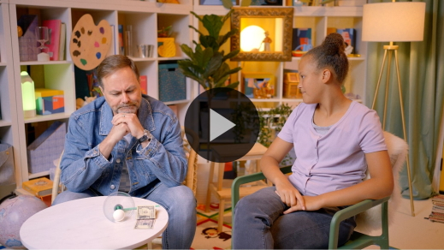

Wow! That church Grandpa told us about sounds pretty awesome. An entire church worked together to help spread God’s love. Do you remember who they helped? *(Allow responses.)* That’s right! They helped Paul, and he helped others. Paul’s life was changed in a big way by God. He found God’s love and couldn’t keep it a secret.

As he traveled and told others about Jesus, their lives changed, too. Paul didn’t have much money. The church didn’t have much money either, but they took what they had and gave it to help spread God’s love.

**Worship**

Paul went to lots of churches and told them about God. He also taught those churches how to worship God together. Worshipping God together is such an awesome thing to do. Let’s do that together now.

**Praise**

Are you glad God loves you? Say, “Thank You, God!” *(Group response)*

Are you happy that you can help others? Clap your hands three times. *(Group response)*

Who wants to tell God you love Him? Wave your hands up high. *(Group response)*

**Sing**

We’ve spent time today learning about the Bible. It tells us how much God loves us. When we worship, we pause and tell God how much we love Him. One way we worship is by singing.

• *Lead the kids in singing one or two songs. See song suggestions at the beginning of the session.*

**Prayer**

I know God loved listening to you sing His praises. It’s really special to worship God together with you. Another way we can spend time with God is by talking to Him. Let’s bow our heads and pray.

|  |
| --- |
| Dear God, it’s so awesome that You want to use us. We want the whole world to know that You love them, but we know we can’t do it on our own. Show us how we can help others go and spread Your love. We love You. Amen. |

**Bible Time cont’d**

I love talking to God. I also love that God talks to us. One of the ways He talks to us is through the Bible. Let’s look at the Bible together with our friend Lizzy.

• *Play* ***Bible Lesson Video B.***

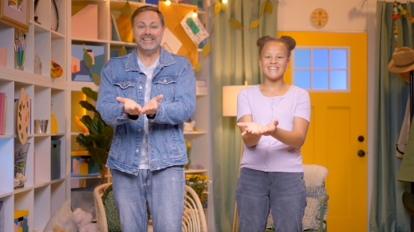

Wow! You’re doing an awesome job learning our Faith Verse. Our verse is about telling everyone that God wants them to be a part of His family. We know we can’t do it on our own. When we work together as God’s family, we can help people know about God’s love.

**Response Time**

Now, we’ll respond to God by letting Him show us what to do with what we’ve learned. Hold out your hand.

• *Give each kid two coins.*

Raise your hand if you remember the church that didn’t have much money to help. *(Group response)* What did they do with the little money they had? *(Allow responses.)* You’re right! They gave it to help Paul tell others about God. Did you know that God can take the little bit of money we have and do big things if we give it to Him? Let’s ask God to show us how we can help others so that they can spread the good news that God loves them. We’ll pray. Then, you choose how much of your money you want to give to missionaries to tell others about God.

• *Optional: Have the kids repeat phrases of the prayer after you.*

|  |
| --- |
| Dear God, I know You can use me to do big things. I want to help missionaries spread Your love to other people. Show me what I should give to help other people go. Amen. |

Our Faith Fact is **I will help others go**. Ask God how many of your coins He wants you to give to help missionaries. Now, put those coins in the offering basket.

• *Give kids time to prayerfully respond. Don’t force them to give both of their coins if they don’t want to.*

Thank you for helping others go with your giving.

• *Optional: If a number of kids didn’t give both coins, tell the group where you will leave the basket in case God speaks to anyone about giving more before they go home. Again, do not pressure them to give.*

**Faith Verse**

God loves it when we listen to Him and ask Him to lead us. He also loves it when we learn Bible verses from His Word. Let’s practice our Faith Verse with the actions.

[Matthew 28:19](https://ref.ly/logosref/Bible.Mt28.19) (NLT)

“Therefore, go and make disciples of all the nations, baptizing them in the name of the Father and the Son and the Holy Spirit.”

• *Show the* ***Faith Verse Slide***.

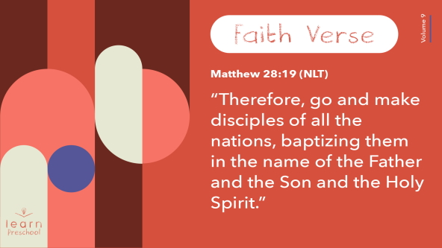

You’re doing an amazing job of learning that verse!

**Closing**

I love that God teaches us so many different things through the Bible. One thing I want you to remember is that we can work together to help others. There are lots of people who need to know about God’s love. We can follow the example of the church that we heard about today who gave money so Paul could go help others.

• *Play the* ***Faith Fact Sound*** *video (bell ringing).*

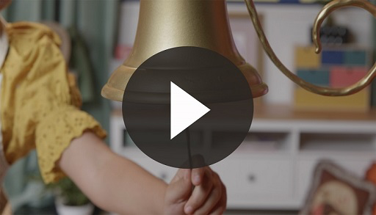

Wait! Did you hear that? That sound means it’s time to say our Faith Fact again: **I will help others go.**

• *Show the* ***Faith Fact Slide.***



Let’s shout it together. Ready? **I will help others go.** Now, we’ll put our hands up in the air and point to the sky with each word we say. *(Demonstrate the action.)* Ready? **I will help others go.** You nailed it!

**Dismissal to Small Groups**

It’s been an awesome time getting to play, praise, and pray with you. Now, it’s time to keep the fun going as we head to our circles and learn some more.

• *Dismiss the kids by groups*.

|  |
| --- |
| ***Leader Tip:*** *This can be done by assigning color teams or by age groups. Note that some young preschoolers may not know their age. Using a colored sticker, jersey, or wristband will help separate the kids and help identify their small groups.* |

**Small Group**

**25 Minutes**

*See supplies and prep instructions at beginning of session or in each activity below.*

|  |
| --- |
| ***Leader Tip:*** *Small groups can alternate to each circle, or all groups can do each activity at the same time. If you choose to alternate, you will need at least one leader per circle.* |

**Circle 1**

**Group Connection**

**How Far Can You Go?**

|  |
| --- |
| ***You Will Need***  *• Small toy cars, one per group*  *No prep needed for this activity.* |

*(Hold up the car.)* Do you like to play with toys like this? *(Group response)* We could spend hours pushing it around the floor. The problem is every time we push it, the car would only go so far. *(Push car away from you on the floor.)* It can go fast for a short while, but then it stops. When it stops, it won’t move unless I push it again.

• *Push car again. When it stops, invite a kid to help you by pushing the car.*

Look how much further it went now because someone else helped me. How far do you think the car would go if we all worked together and each one takes a turn? *(Allow response.)* Do you think the car could make it all the way across the room? *(Group response)* Let’s try! One more thing. Each time someone pushes the car, we have to say our Faith Fact together. **I will help others go.**

• *Give kids time to complete this activity.*

We did it! We made it all the way across the room. It’s great to work together like our Faith Fact says. Let’s say our Faith Fact one more time. **I will help others go.**

**Circle 2**

**Activity Page Time**

**Mission Connection**

|  |
| --- |
| ***You Will Need***  *•* ***Small Group Activity Page****, one per kid*  *• Crayons or markers*  ***Getting Ready***  *• Print copies of the* ***Small Group Activity Page****, one per kid.* |

Did you know we are on a mission? *(Group response)* God gave us a mission to share His love with others so they could be a part of His family. Our Faith Verse is about that. Can you say it with me?

• *Lead kids in saying the verse with actions.*

[Matthew 28:19](https://ref.ly/logosref/Bible.Mt28.19) (NLT)

“Therefore, go and make disciples of all the nations, baptizing them in the name of the Father and the Son and the Holy Spirit.”

• *Hand out a copy of the* ***Small Group Activity Page*** *and crayons to each kid.*

Great job! Today’s page is about our mission. On your page, you’ll see a bunch of dots that make up letters, but I need your help to know what it says. Your job is to connect the dots to reveal something God wants us to do.

• *While kids are tracing the letters, be ready to assist them.*

• *During the activity, interrupt and practice the Faith Fact:* **I will help others go.**

• *Play the* ***Faith Fact Sound*** *video. Review the Faith Fact even if you can’t play the sound.*



Wow, that was no challenge for you! You did an incredible job. Can you guess what it says? *(Allow responses.)* Today, we’ve learned a Faith Fact about what God wants us to do. That’s what you just wrote on your page. Let’s say it together. **I will help others go.**

**Circle 3**

**Feet-to-Floor Game Time**

**Full Send**

|  |
| --- |
| ***You Will Need***  *• Suitcase, one per group*  *• Bucket, one per group*  *• Table tennis balls, at least ten per group*  *•* ***Countdown60 Video****–60 seconds*  ***Getting Ready***  *• Place the table tennis balls in the bucket and place it on one side of the room.*  *• Place the opened suitcase across from the bucket of table tennis balls.* |

It’s game time! Who’s ready to get the wiggles out and play a game? *(Group response)* We’re going to see how quickly we can give so others can go.

The goal of the game is to send all the balls from our bucket across the room to the suitcase. The catch is only one person can move at a time. When it’s your turn, you’ll take a ball and run as fast as you can and drop it in the suitcase. Then, you’ll run back and tag the next person in line. Do you think we can go and give all of these balls in one minute? *(Group response)* Let’s find out!

• *Play the* ***Countdown60 Video****–60 seconds****.***



• *Play until time is up.*

Let’s count how many balls we were able to give. Then, let’s yell the Faith Fact: **I will help others go.**

• *Count out loud the number of balls in the suitcase. Then, say the Faith Fact.*

Wow! You did a great job working together. You could try to do it on your own, but God wants us to remember to help each other like the church helped Paul to go and tell others about God. I like how you helped each other go.

**Circle 4**

**Hands-On Learning**

**Away We Go**

|  |
| --- |
| ***You Will Need***  *• String or yarn, four feet long, one per group*  *• Ring cereal*  *• Masking tape*  ***Getting Ready***  *• Tape ends of the string to make it easier to thread cereal on the string or yarn.* |

*(Hold up a single piece of cereal and the string.)* Imagine this cereal represents people who don’t know about God’s love yet. This string represents us telling them about God’s love. Will I share God’s love with all these people if I try to do it on my own or if we work together? *(Group response)*

• *Slide cereal piece on the string.*

• *Give each kid some cereal pieces.*

My cereal piece is by itself on the string. Let’s say that means I told one person about God’s love. Just as it would take me a long time to put all this cereal on the string, it would take one person a long time to tell the whole world about God’s love. That one person couldn’t go very far or very fast. When we take what we have, give it to other people, and allow them to spread God’s love too, then we can tell a lot more people how much God loves them. Let’s work together and see how many we can add to our string.

• *Have kids take turns adding cereal to the string until times runs out.*

**Dismissal**

• *Play the* ***Faith Fact Sound*** *video (bell ringing).*



• *Show the* ***Faith Fact Slide.***



I can’t believe it’s time to go already. Let’s say the Faith Fact together one last time. **I will help others go.** Great job! I had a great time learning more about God’s Word with you. See you next time.

• *Send home the* ***Small Group Activity Page*** *with each kid.*

• *Remind parents that there are* ***Family Devotions*** *available on the app to do with their kid.*

• *Tell everyone the date and time for the next session.*

.